**CHAPTER 5**

**RESULTS AND DISCUSSION**

When there is a bus failure on an ongoing journey, the passengers go into a dilemma whether to wait there for help to arrive or to move by private vehicle. Nowadays, the increase in harmful gases in the atmosphere is causing damage to human life.

The difficulties faced by people when a bus fails or one fails to board the bus on time lead to confusion among the people. Also, air pollution is one of the major environmental issues that cannot be ignored. Inhaling pollutants for a long time causes damage to human health.

To overcome this problem this is to build an *"Android application"* which will help us track the bus locations and monitor the air pollution levels in the environment through a mobile application. And this application provides the information and location of bus and amount of pollution during the journey of various places to the stake holders for taking care and prior precautions.

Being able to track the location of your bus in real-time. With a bus tracking system, you can do just that! A bus tracking system can help our organization improve transportation efficiency and optimize routing. It can also help you track the whereabouts of buses and passengers in real-time, giving you complete visibility into your bus operations.

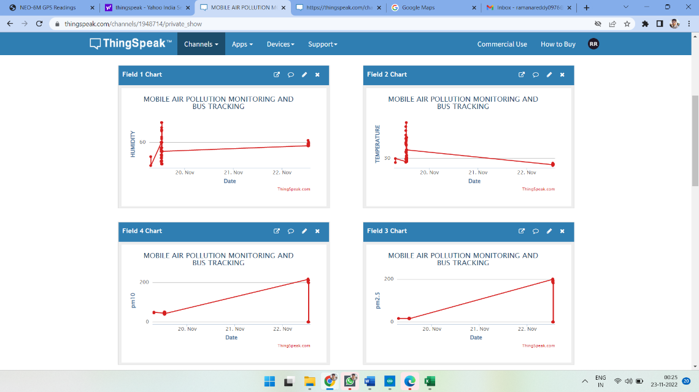

Fig 5.1 bvdjbfirhjkwhfajlksjoeiuwbalfefn

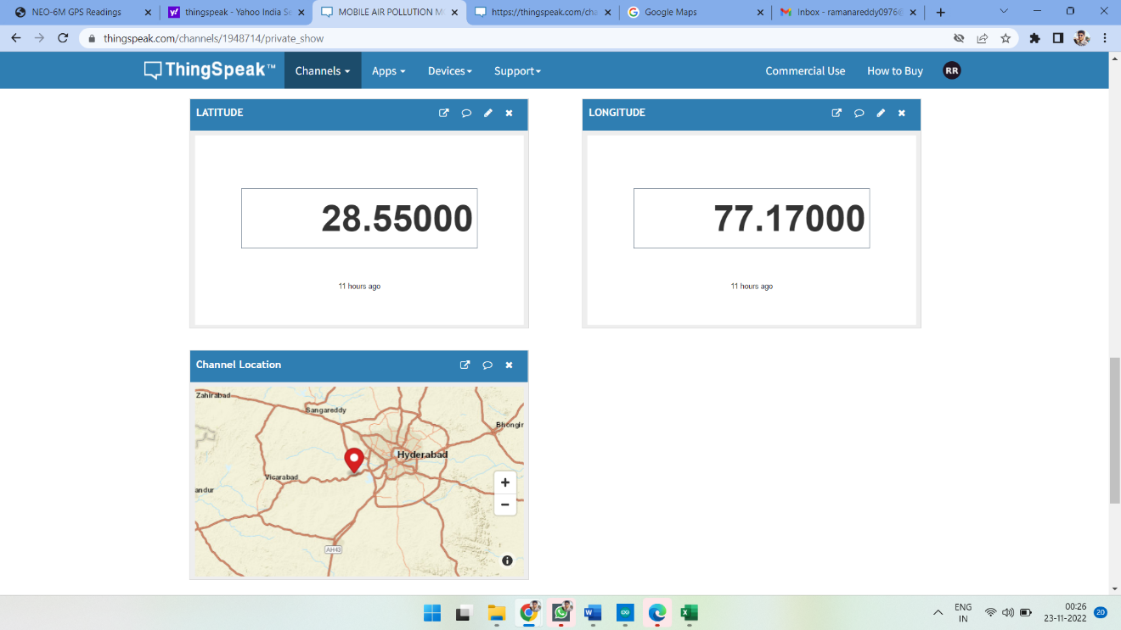

Fig 5.2 bdhfeojfndhol[[0p9eioubfndmcs,

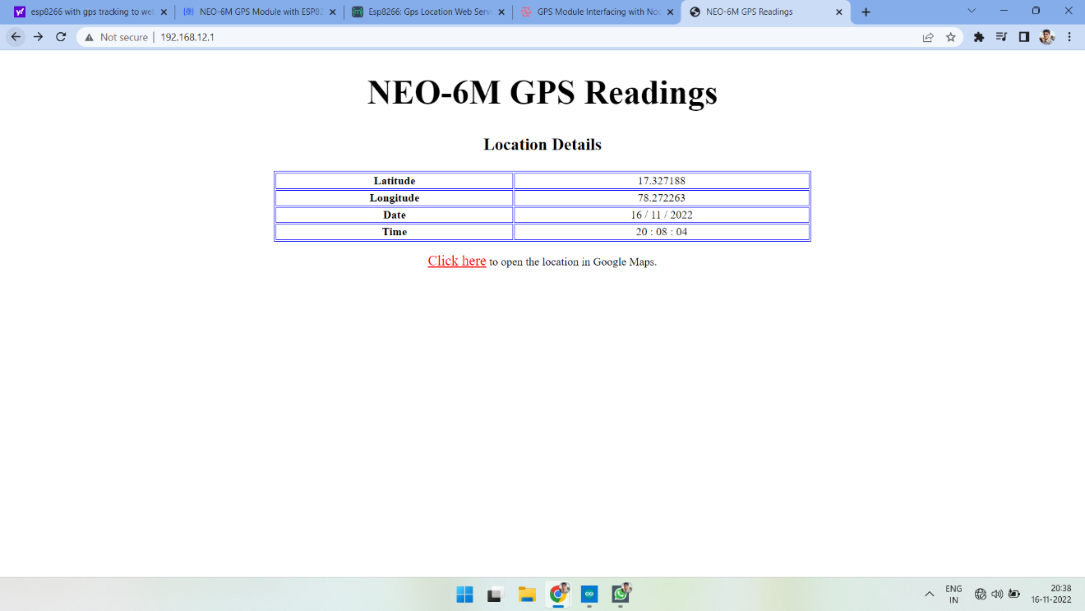

Fig 5.3 rjkndlsjkfoiwhsnlk

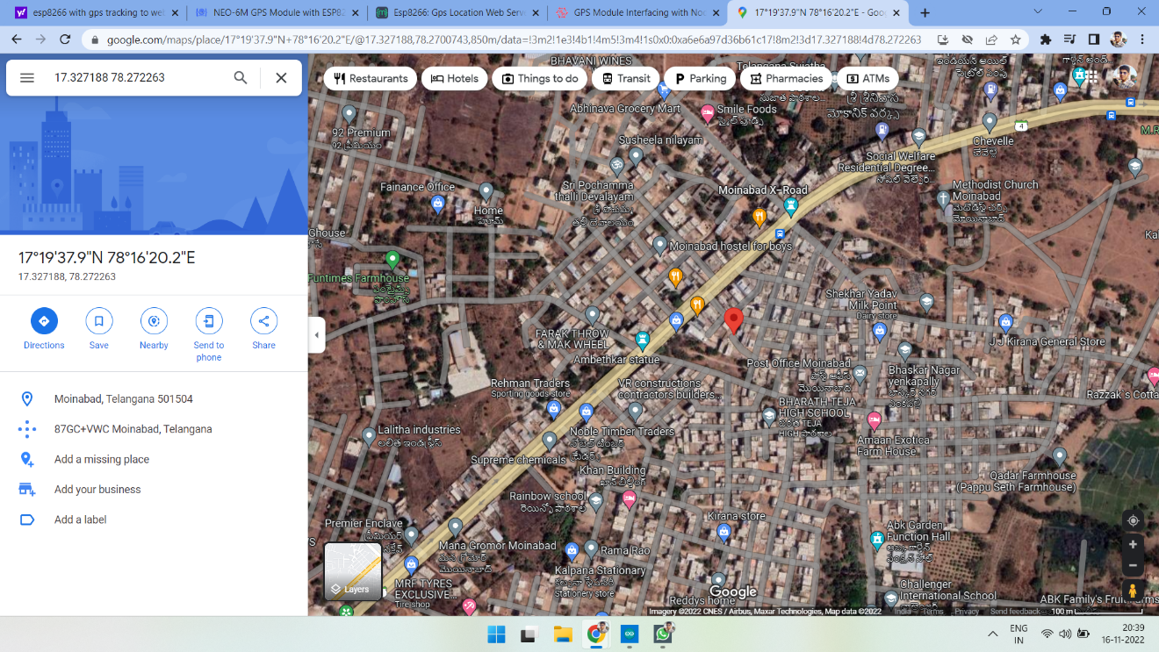

Fig 5.4 dnbihwospaikfw--=olda,pfmosfineu

Circuit photo

**CHAPTER 6**

# CONCLUSION AND FUTURE SCOPE

# 6.1 CONCLUSION

The project titled “**MOBILE AIR POLLUTION MONITORING AND BUS TRACKING**” is a model for bus tracking unit with the help of gps receivers and GSM modem and it is better scheduling or route planning can enable you handle larger jobs loads within a particular time. Bus tracking both in case of personal as well as business purpose improves safety and security, communication medium, performance monitoring and increases productivity.

As well as the air pollution monitoring will be done parallelly, the different areas have different levels of air quality at different times it is important for us to monitor what is happening. In this way we can identify trouble spots and ensure that we are taking the right steps. So, in the coming year, it is going to play a major role in our day-to-day living. We have completed the project as per the requirements of our project.

# 

# 6.2 FUTURE SCOPE

1. The proposed system can be connected to a GSM module and when the air pollution levels cross a certain threshold, it can immediately alert the local pollution board and other concerned parties.

2. We can reduce the size of the kit and increase accuracy up to 3m by using more standard GPS receivers.

The proposed system can be modified and can also be upgraded as:

E.g., “**To make more effective and real time we can add air purifier to the existing model”** which might also be bit complex.

# 

# REFERENCES

[1] P. Das, S. Ghosh, S. Chatterjee and S. De, "A Low Cost Outdoor Air Pollution Monitoring Device With Power Controlled Built-In PM Sensor," in IEEE Sensors Journal, vol. 22, no. 13, pp. 13682-13695, 1 July1, 2022, doi: 10.1109/JSEN.2022.3175821.

[2] M. F. M. A. Hakeem, N. A. Sulaiman, M. Kassim and N. M. Isa, "IoT Bus Monitoring System via Mobile Application," 2022 IEEE International Conference on Automatic Control and Intelligent Systems (I2CACIS), 2022, pp. 125-130, doi: 10.1109/I2CACIS54679.2022.9815268.

[3] B. B. Humaïra and A. Chiniah, "An Adaptive Communication Model for Android Bus Tracking App," 2021 2nd Global Conference for Advancement in Technology (GCAT), 2021, pp. 1-6, doi: 10.1109/GCAT52182.2021.9587657.

[4] T. W. Ayele and R. Mehta, "Air pollution monitoring and prediction using IoT," 2018 Second International Conference on Inventive Communication and Computational Technologies (ICICCT), 2018, pp. 1741-1745, doi: 10.1109/ICICCT.2018.8473272.

[5] V. Shakhov and O. Sokolova, "On Modeling Air Pollution Detection With Internet of Vehicles," 2021 15th International Conference on Ubiquitous Information Management and Communication (IMCOM), 2021, pp. 1-3, doi: 10.1109/IMCOM51814.2021.9377350.

[6] R. S. Krishnan, S. Manikandan, J. R. F. Raj, K. L. Narayanan and Y. H. Robinson, "Android Application based Smart Bus Transportation System for Pandemic Situations," 2021 Third International Conference on Intelligent Communication Technologies and Virtual Mobile Networks (ICICV), 2021, pp. 938-942, doi: 10.1109/ICICV50876.2021.9388625.

[7] H. Gull, D. Aljohar, R. Alutaibi, D. Alqahtani, M. Alarfaj and R. Alqahtani, "Smart School Bus Tracking: Requirements and Design of an IoT based School Bus Tracking System," 2021 5th International Conference on Trends in Electronics and Informatics (ICOEI), 2021, pp. 388-394, doi: 10.1109/ICOEI51242.2021.9452818.

[8] S. A. E. Yosif, M. M. Abdelwahab, M. Abd Elrahman ALagab and F. Muhammad, "Design of bus tracking and fuel monitoring system," 2017 International Conference on Communication, Control, Computing and Electronics Engineering (ICCCCEE), 2017, pp. 1-5, doi: 10.1109/ICCCCEE.2017.7867679.

[9] R. Akter, M. J. H. Khandaker, S. Ahmed, M. M. Mugdho and A. K. M. B. Haque, "RFID based Smart Transportation System with Android Application," 2020 2nd International Conference on Innovative Mechanisms for Industry Applications (ICIMIA), 2020, pp. 614-619, doi: 10.1109/ICIMIA48430.2020.9074869.

[10] H. Liu, H. Xu, Y. Yan, Z. Cai, T. Sun and W. Li, "Bus Arrival Time Prediction Based on LSTM and Spatial-Temporal Feature Vector," in IEEE Access, vol. 8, pp. 11917-11929, 2020, doi: 10.1109/ACCESS.2020.2965094.

[11] P. Ferrer-Cid, J. M. Barcelo-Ordinas and J. Garcia-Vidal, "Graph Learning Techniques Using Structured Data for IoT Air Pollution Monitoring Platforms," in IEEE Internet of Things Journal, vol. 8, no. 17, pp. 13652-13663, 1 Sept.1, 2021, doi: 10.1109/JIOT.2021.3067717.

[12] B. Perumal, J. Deny, K. Alekhya, V. Maneesha and M. Vaishnavi, "Air Pollution Monitoring System by using Arduino IDE," 2021 Second International Conference on Electronics and Sustainable Communication Systems (ICESC), 2021, pp. 797-802, doi: 10.1109/ICESC51422.2021.9533007.

[13] K. Ammar, M. Jalmoud, A. Boushehri and K. Fakhro, "A Real-time School Bus Tracking and Monitoring System," 2019 IEEE 10th Annual Information Technology, Electronics and Mobile Communication Conference (IEMCON), 2019, pp. 0654-0660, doi: 10.1109/IEMCON.2019.8936199.

[14] S. Akter, T. Islam, R. F. Olanrewaju and A. A. Binyamin, "A Cloud-Based Bus Tracking System Based on Internet-of-Things Technology," 2019 7th International Conference on Mechatronics Engineering (ICOM), 2019, pp. 1-5, doi: 10.1109/ICOM47790.2019.8952037.

[15] M. A. Hafiizh Nur, S. Hadiyoso, F. B. Belladina, D. N. Ramadan and I. Wijayanto, "Tracking, Arrival Time Estimator, and Passenger Information System on Bus Rapid Transit (BRT)," 2020 8th International Conference on Information and Communication Technology (ICoICT), 2020, pp. 1-4, doi: 10.1109/ICoICT49345.2020.9166375.

[16] K. Premkumar, P. K., P. J., P. D. and P. P., "College Bus Tracking and Notification System," 2020 International Conference on System, Computation, Automation and Networking (ICSCAN), 2020, pp. 1-4, doi: 10.1109/ICSCAN49426.2020.9262303.